Project Design Phase-II
Data Flow Diagrams and User Stories
Date | 07/07/2026
Team ID | SWTID-2026-9649
Project Name | Sports Hall Booking System by Service Portal(ServiceNow)
Maximum Marks | 4 Marks

Data Flow Diagram (DFD)

A Data Flow Diagram represents how data moves through the Sports Hall Booking System. It shows the interaction between users, administrators, system processes, and stored data.
Level 0 DFD – Context Diagram

The main external entities are:
User: Views sports hall information, submits booking details, checks booking status, and manages bookings.
Administrator: Manages sports halls, booking records, and system operations.
Sports Hall Booking System: Processes booking requests, validates information, stores records, and provides booking updates.
Main flow:

User → Booking Request → Sports Hall Booking System → Booking Status / Confirmation → User
Administrator ↔ Sports Hall Booking System ↔ Hall and Booking Records

Level 1 DFD

The system can be divided into the following major processes:
Process ID | Process Name | Description
1.0 | View Sports Halls | Retrieves and displays available sports hall information to users.
2.0 | Submit Booking Request | Accepts hall selection, date, time, and other booking details.
3.0 | Validate Booking | Checks booking information and helps prevent scheduling conflicts.
4.0 | Manage Booking Records | Creates, updates, and maintains booking information.
5.0 | Send Notifications | Provides booking confirmation and status-related updates.
6.0 | Admin Management | Enables administrators to manage sports halls and booking records.

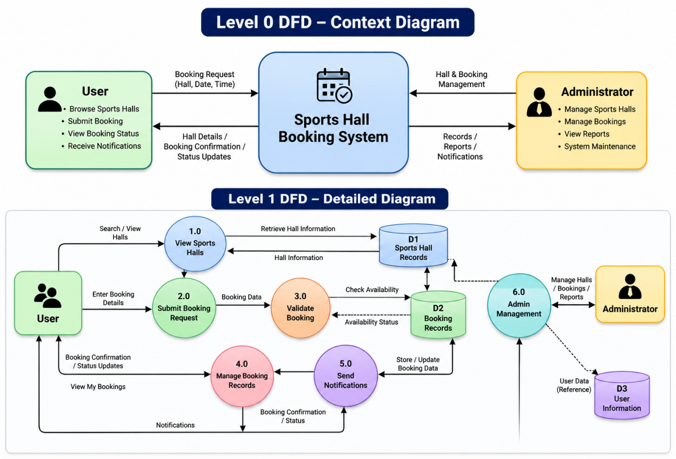

Data Stores
ID/No. | Description
D1 | Sports Hall Records: Stores sports hall and facility information.
D2 | Booking Records: Stores booking details, dates, times, users, and booking status.
D3 | User Information: Stores or references information associated with system users.

User Stories
User stories describe system requirements from the perspective of the people who interact with the Sports Hall Booking System.

User Story No. | User Story | Priority
US-1 | As a user, I want to view available sports halls so that I can choose a suitable facility. | High
US-2 | As a user, I want to view sports hall details so that I can make an informed booking decision. | High
US-3 | As a user, I want to submit a booking request for my preferred date and time. | High
US-4 | As a user, I want the system to validate booking details so that scheduling conflicts can be reduced. | High
US-5 | As a user, I want to view my bookings so that I can track my reservations. | High
US-6 | As a user, I want to receive booking status updates and notifications. | High
US-7 | As an administrator, I want to add and update sports hall information so that facility records remain accurate. | High
US-8 | As an administrator, I want to manage booking records so that reservations are properly organized. | High
US-9 | As an administrator, I want automated processes to reduce repetitive manual work. | Medium
US-10 | As an administrator, I want reports and dashboards to monitor booking information. | Medium

Conclusion

The Data Flow Diagram explains how booking-related information moves between users, administrators, system processes, and data stores. The user stories define the key functional requirements of the Sports Hall Booking System using ServiceNow from both the user and administrator perspectives.

